MAHARASHTRA STATE BOARD OF TECHNICAL EDUCATION

# VIDYAVARDHINI’S BHAUSAHEB VARTAK POLYTECHNIC ,VASAI ROAD WEST

**MICRO PROJECT**

**Academic year: 2021-22**

Title of Micro Project:

**Develop a Store management application**

**Program/Code:** Computer Engineering (CO) **Semester:** THIRD

**Course/Code: Object Oriented Programming using C++ (22316)**

**Name:** : **Siyan Rajesh Pereira Roll No:1122**

**Enrolment No.:2000930022**

**Name of Faculty:** Mrs. Kshipra Mokashi



# MAHARASHTRA STATE BOARD OF TECHNICAL EDUCATION

**Certificate**

This is to certify that Mr. /Ms. : **Siyan Rajesh Pereira**

Roll No. **1122** of **THIRD** Semester of Diploma in of Computer Engineering (CO) Institute, B.V. POLYTECHNIC (Code: **0093**) has completed the **Micro Project** satisfactorily in **Subject – object oriented programming (22316)** for the academic year 2021- 2022 as prescribed in the curriculum.

Place: Vasai Enrolment No: 2000930022

Date: …………… Exam. Seat No: …………………………………….

## Subject Teacher Head of the Department Principal

**Seal of Institution**

Annexure - I

### Part A: Micro Project Proposal

1.1 Aim/Benefits of the Micro-Project:

The aim is to develop applications using OOP’s concepts in C++

* 1. **Course Outcomes integrated:**
     1. **Develop C++ programs to solve problems using procedure oriented approach**
     2. **Develop C++ programs using classes and objects**
     3. **Implement inheritance in C++ program**
     4. **Use polymorphism in C++ program**
     5. **Develop C++ programs to perform file operations**
  2. **Proposed Methodology:**
     1. Collect information through different sources
     2. Analysis of data.
     3. Compilation of collected data.

4.0 Action Plan

|  |  |  |  |  |
| --- | --- | --- | --- | --- |
| **Sr.**  **No.** | **Details of the activity** | **Planned**  **Start date** | **Planned**  **Finish date** | **Name of**  **Members** |
| 1 | Formation of Group & Topic Selection | 21/10/21 | 27/10/21 | All members |
| 2 | Submission of Proposed Plan | 27/10/21. | 01/11/21 | All members |
| 3 | Preparation of Report | 01/11/21. | 7/11/21 | All members |
| 4 | Final valuation of a working Report | 07/11/21. | 14/11/21 | All members |
| 5 | Presentation of Report | 14/11/21. | 28/11/21 | All members |
| 6 | Submission of Final Report | 28/11/21. | 04/12/21 | All members |

5.0 Resource Required:

|  |  |  |  |  |
| --- | --- | --- | --- | --- |
| **Sr.**  **No.** | **Name of resources/Material** | **Specifications** | **Qty** | **Remarks** |
| 1. | Computer | Processor: i3 RAM : 4.00 GB | **1** |  |
| 2. | Microsoft Word | Word -2016 |  |  |
| 3. | Printer | Hp Laser Jet | **1** |  |
| 4. | Book/ website name | Javapoint.com Wikipedia.com |  |  |

6.0 Name of Team Members with Roll No:

|  |  |  |  |  |  |
| --- | --- | --- | --- | --- | --- |
| **Sr.**  **No.** | **Roll No** | **Name of Students** | **Process and Product assessment (06)** | **Individual Presentation (04)** | **Total (10)** |
| 01 | 1122 | Siyan pereira |  |  |  |
| 02 | 1123 | Krishita pawar |  |  |  |
| 03 | 1124 | Rishi kashiya |  |  |  |

**Name & Signature of Faculty: Mrs.** Kshipra Mokashi

Annexure- II

### Final Micro Project Report

Title: Develop a Store management application

application

Rationale: The aim is to develop applications using OOP’s concepts in C++

1. **0 Course Outcomes Integrated**:
   1. **Develop C++ programs to solve problems using procedure oriented approach**
   2. **Develop C++ programs using classes and objects**
   3. **Implement inheritance in C++ program**
   4. **Use polymorphism in C++ program**
   5. **Develop C++ programs to perform file operations**
   6. **Actual Procedure Followed.**
      1. Discussion about topic with guide and among group members
      2. Information collection
      3. Compilation of content
      4. Editing and revising content
      5. Report Preparation

**4.0: Actual Resources Required:**

|  |  |  |  |  |
| --- | --- | --- | --- | --- |
| **Sr.**  **No.** | **Name of resources/Material** | **Specifications** | **Qty** | **Remarks** |
| 1. | Computer | Processor: i3 RAM : 4.00 GB | 1 |  |
| 2. | Microsoft Word | Word -2016 |  |  |
| 3. | Printer | Hp Laser Jet | 1 |  |
| 4. | Book/Site name | Javapoint.com Wikipedia.com |  |  |

7.0 Skill Developed/Learning outcomes of this Micro-Project

The following skills were developed:

1. **Teamwork:** Learned to work in a team and boost individual confidence.
2. **Problem-Solving:** Developed good problem solving habits.
3. **Technical Writing:** Preparing the report of proposed plan and the final report.

### Rubrics for Assessment of Micro-Project

Annexure - III

**Title:** Develop a Store management application

**Institute Code:** 0093 **Academic year:** 2021-22

**Program: CO Course & Code: OOP (22316)**

Name of Candidate: Roll No: 1122

Semester: THIRD Name of Faculty: Mrs.Kshipra Mokashi

|  |  |  |  |  |  |
| --- | --- | --- | --- | --- | --- |
| **Sr.**  **No.** | **Characteristic to be Assessed** | **Poor**  (Marks 1-3) | **Average**  (Marks 4-5) | **Good**  (Marks 6-8) | **Excellent**  (Marks 9-10) |
| 1. | Relevance to the Course |  |  |  |  |
| 2. | Literature Survey/Information Collection |  |  |  |  |
| 3. | Project Proposal |  |  |  |  |
| 4. | Completion of the Target as per Project Proposal |  |  |  |  |
| 5. | Analysis of Data and Representation |  |  |  |  |
| 6. | Quality of Prototype/Model |  |  |  |  |
| 7. | Report Preparation |  |  |  |  |
| 8. | Presentation |  |  |  |  |
| 9. | Viva |  |  |  |  |

Annexure- IV

## Micro-Project Evaluation Sheet

Title: Develop a Store management application

**Institute Code:** 0093 **Academic year:** 2021-22

Program: CO Course & Code: OOP (22316)

Name of Candidate: siyan rajesh pereira Roll No: 1122

Semester: THIRD Name of Faculty: Mrs. Kshipra Mokashi

Course Outcomes Achieved:

* 1. **Develop C++ programs to solve problems using procedure oriented approach**
  2. **Develop C++ programs using classes and objects**
  3. **Implement inheritance in C++ program**
  4. **Use polymorphism in C++ program**
  5. **Develop C++ programs to perform file operations**

Evaluation as per Suggested Rubric for Assessment of Micro Project:

|  |  |  |  |  |  |  |
| --- | --- | --- | --- | --- | --- | --- |
| **Sr.**  **No.** | **Characteristic to be assessed** | **Poor Marks 1-3** | **Average Marks 4-5** | **Good Marks 6-8** | **Excellent Marks 9-10** | **Sub Total** |
| **(A) Process and product assessment Out Of 6** | | | | | | |
| 1 | Relevance to the course |  |  |  |  |  |
| 2 | Literature Survey Information Collection |  | . |  |  |
| 3 | Completion of the Target as per project proposal |  |  |  |  |
| 4 | Analysis of Data and representation |  |  |  |  |
| 5 | Quality of Prototype/Model/Conte nt |  |  |  |  |
| 6 | Report Preparation |  |  |  |  |
| **(B) Individual Presentation/Viva Out of 4** | | | | | | |
| 7 | Presentation | . |  |  |  |  |
| 8 | Viva |  |  |  |  |
| **Name and designation of the Faculty Member: Mrs.Kshipra Mokashi** | | | | | | |

## Weekly Activity Sheet

Topic: Develop a Store management application

**Institute Code:** 0093 **Academic year:** 2021-22

Program: CO-1 Course & Code: OOP (22316)

**Name of Candidate**: Siyan Rajesh PE **Roll No: 1122**

Semester: THIRD Name of Faculty: Mrs. Kshipra Mokashi

|  |  |  |
| --- | --- | --- |
| **SR. NO** | **WEEK** | **ACTIVITY PERFORMED** |
| 1. | 1st Week | Discussion and Finalization of Topic |
| 2. | 2nd Week | Literature Review |
| 3. | 3rd Week | Submission of Proposed Plan |
| 4 | 4th Week | Information Collection |
| 5. | 5th Week | Analysis of Data |
| 6. | 6th Week | Compilation of content |
| 7. | 7th Week | Editing and Revising the Content |
| 8. | 8th Week | Report Preparation |
| 9. | 9th Week | Report Preparation |
| 10. | 10th- 12th Week | Presentation |

Signature of Student Dated Signature of Faculty

ABOUT PROJECT

Store Management System is based on a concept to record, refilled items, sold items , and profit made by selling items . The user can add items, display remaining stocks , refill stocks and sell it.

Talking about the features of Store Management System, while adding items The user has to provide product name, price, and amount. Similarly while refilling items, the user has to enter the product code to select the product, then he/she has to enter amount. Selling an item is too easy, he/she just has to provide product name and price. The system displays Particulars (product code) with Available amount and Price .

Store Management system is developed using C++ Programming Language and different variables.

**Features:**

1. Show all stored items
2. Edit item
3. Add a new item
4. Sell an item
5. Total money earned
6. Show total items sold

Work done by members

|  |  |  |
| --- | --- | --- |
| Information gathering | Improving the code | Compiling the code and editing the file |
| 1207 Swaine Rodrigues  1208 Mansi Jadhav | 1207 Swaine Rodrigues  1208 Mansi Jadhav  1209 Sharian Dabre | 1209 Sharian Dabre |

//1207_Swaine Rodrigues

//1208_Mansi Jadhav

//1209_Sharian Dabre

#include <iostream>

#include <conio.h>

#include <stdlib.h>

#include <iomanip>

using namespace std;

const int m = 20;

class dept

{

  int amount[m], pris[m], k, a, b, amount1;

  int code1, cod[m], s, last, code;

public:

  float price1, price;

  dept(void);

  void sell(void);

  void total_items(void);

  void add_old(void);

  void add_new(void);

  void show(void);

  void menu(void);

};

dept::dept(void)

{

  s = 0;

  a = 10;

  b = 40;

  last = 5;

  amount[0] = 0;

  for (int k = 0; k < last; k++)

  {

    s = s + 1;

    b = b + 10;

    cod[k] = s;

    amount[k] = a;

    pris[k] = b;

  }

}

void dept::add_old(void)

{

  system("cls");

  cout << "\nEnter item code:";

  cin >> code1;

  cout << "\nEnter item price:";

  cin >> price1;

  for (k = 0; k < last; k++)

  {

    if (code1 == cod[k])

    {

      a = a + 1;

      amount[k] = a;

      pris[k] = price1;

    }

  }

  cout << "Enter 0 for Main menu ::";

}

void dept::add_new(void)

{

  system("cls");

  cout << "\nEnter item code:";

  cin >> code1;

  cout << "\nEnter amount of that item:";

  cin >> amount1;

  cout << "\nEnter item price:";

  cin >> price1;

  cod[last] = code1;

  amount[last] = amount1;

  pris[last] = price1;

  last++;

  cout << setw(40);

  cout << "Enter 0 for Main menu ::";

}

void dept::show(void)

{

  system("cls");

  for (k = 0; k < last; k++)

  {

    cout << setw(40);

    cout << "CODE:" << cod[k] << "\t";

    cout << "AMOUNT:" << amount[k] << "\t";

    cout << "PRICE:" << pris[k] << endl;

    cout << endl;

  }

  cout << "//-----------------------------------------------------------------------------------------------------------------\\" << endl;

  cout << endl;

  cout << setw(40);

  cout << "Enter 0 for Main menu ::";

}

void dept::sell(void)

{

  cout << setw(40);

  cout << "Enter product code:";

  cin >> code;

  cout << setw(40);

  cout << "Enter product price:";

  cin >> price;

  cout << endl;

}

void dept::total_items(void)

{

  cout<<endl;

  cout<<endl;

  cout << setw(40);

  cout << "ITEM CODE:"

       << code << "\t";

  cout << setw(40);

  cout << "ITEM PRICE:"

       << price << "\t";

  cout << endl;

}

void dept::menu(void)

{

  system("cls");

  cout << "<<------------------------------------------------------------------------------------->>>" << endl;

  cout << setw(60);

  cout << "---CHOOSE A NUMBER---" << endl;

  cout << endl;

  cout << setw(50);

  cout << " Main menu .0" << endl;

  cout << endl;

  cout << setw(50);

  cout << " Show all stored items .1" << endl;

  cout << endl;

  cout << setw(50);

  cout << " Edit item .2" << endl;

  cout << endl;

  cout << setw(50);

  cout << " Add a new item .3" << endl;

  cout << endl;

  cout << setw(50);

  cout << " Sell an item .4" << endl;

  cout << endl;

  cout << setw(50);

  cout << " Total money earned .5" << endl;

  cout << endl;

  cout << setw(50);

  cout << " Show total items sold .6" << endl;

  cout << endl;

  cout << setw(50);

  cout << " Quit .7" << endl;

  cout << endl;

  cout << "<<------------------------------------------------------------------------------------->>>" << endl;

  cout << endl;

  cout << setw(48);

  cout << "Enter Your Choice ::";

}

int main()

{

  int size;

  dept d[10], print;

  static int j = 0;

  int x, i = 0, p, s = 0;

  print.menu();

  do

  {

    cin >> x;

    switch (x)

    {

    case 1:

      d[i].show();

      break;

    case 2:

      d[i].add_old();

      d[i].show();

      break;

    case 3:

      d[i].add_new();

      d[i].show();

      break;

    case 4:

      system("cls");

      cout << setw(40);

      cout << "How many items you want to sell :";

      cin >> size;

      for (int i = 0; i < size; i++)

      {

        cout << endl;

        d[i].sell();

      }

      i++, j++;

      cout << setw(40);

      cout << "Item sold" << endl;

      cout << endl;

      cout << setw(40);

      cout << "Enter 0 for Main menu ::";

      ;

      break;

    case 5:

    {

      system("cls");

      cout << setw(40);

      cout<<endl;

      cout<<endl;

      cout << "Money earned:"<<"\t";

      s = 0;

      for (p = 0; p < size; p++)

      {

        s = s + d[p].price;

      }

      cout << s << "Rupees.\n";

      cout << endl;

      cout << setw(40);

      cout << "Enter 0 for Main menu ::";

    }

    break;

    case 6:

      system("cls");

      for (int i = 0; i < size; i++)

      {

        d[i].total_items();

      }

       cout << "//----------------------------------------------------------------------------------------------------------------->>" << endl;

      cout << setw(40);

      cout<<endl;

      cout<<endl;

      cout<<endl;

      cout << "Enter 0 for Main menu ::";

      break;

    case 7:

      break;

    case 0:

      system("cls");

      d[i].menu();

      break;

    }

  } while (x != 7);

  getch();

  return 0;

}

Output:

Main menu.1

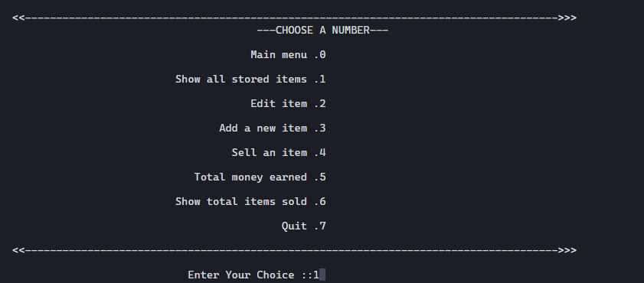

Show all stored items .1

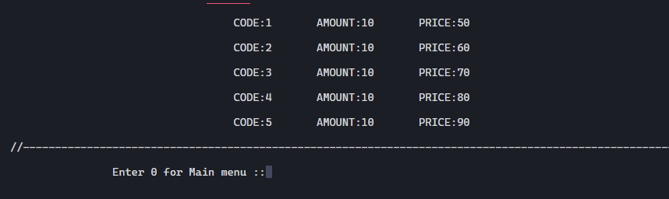

Edit item .2

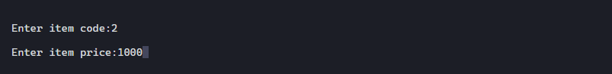

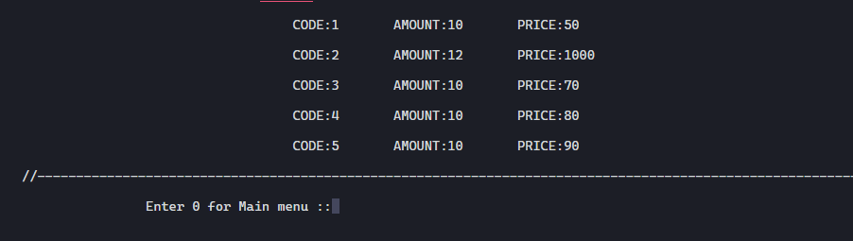

Add a new item .3

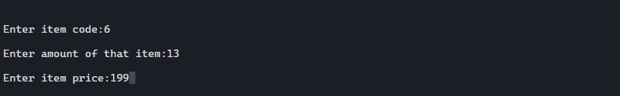

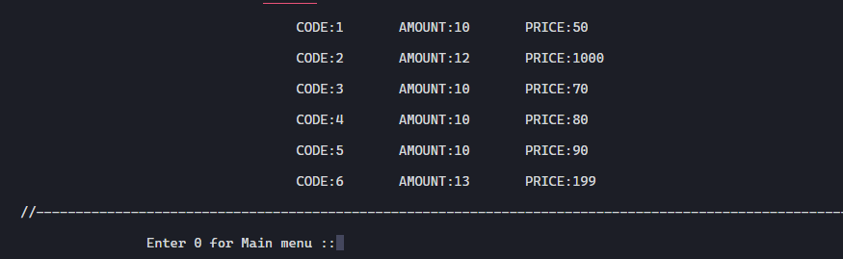

Sell an item .4

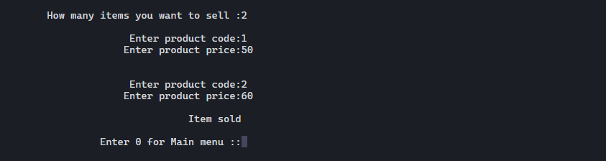

Total money earned .5



Show total items sold .6

